
MEV Disegno
Contact: Mario Escalante
Mobile: +5255 4552 4454
contact@thespiritofmev.com

July 8, 2024
FOR IMMEDIATE RELEASE
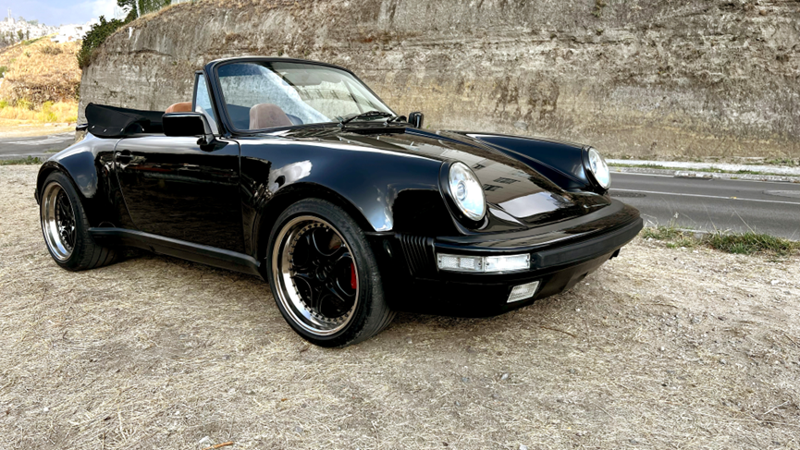
MEV DISEGNO INTRODUCES THE OPUS1 GB, ITS FIRST RESTOMOD SERIES BASED ON THE PORSCHE 911G LIMITED TO 20 CARS.

Mexico City, June 28, 2024 – MEV Disegno (https://thespiritofmev.com), the first Porsche restomod studio based in Mexico City, is proud to announce the launch of its OPUS1 GB series. This limited-edition series, restricted to just twenty unique vehicles, celebrates the iconic Porsche 911G, a classic revered for its distinctive style and performance.
The OPUS1 GB: A Masterpiece of Craftsmanship and Innovation
Each OPUS1 GB build is a testament to MEV Disegno's commitment to excellence. The company focuses on preserving the timeless beauty of the G-generation of the Porsche 911 while incorporating enhancements and modern tech that elevate its performance, comfort, and style.
Highlights of the OPUS1 GB Series:
- Exclusive and Limited: Only 20 units of the OPUS1 GB will be produced, each uniquely numbered, exquisitely built, and tailored to the owner's specifications and driving style, ensuring unparalleled exclusivity and personalization.
- Classic Design with Modern Upgrades: The OPUS1 GB retains the classic lines and aesthetics of the Porsche 911. The exterior and trims are carefully restored, with modifications made to enhance the car's original beauty and functionality.
- Luxurious Interiors: Inside, the OPUS1 GB features a beautifully redesigned interior in premium custom leather seats, customized Nardi steering wheel, a premium sound system, and modern conveniences like Bluetooth connectivity and hands-free-calling. The interior also includes polished aluminum controls, a custom central console, and LED lighting all around among the countless details providing a comfortable and luxurious driving experience.
- Enhanced Performance: Owners may maintain their car’s original specs or choose to enhance them with upgrade options such as a more powerful engine, modern electronic injection system, and adjustable suspension among other. These enhancements ensure a thrilling and dynamic driving experience while preserving the car's original essence.
- Attention to Detail: Every OPUS1 GB build showcases meticulous attention to detail. From the impeccably executed upholstery to the plated or anodized metallic parts, custom LED lighting, and optional duffel bags in matching leather. Each element is crafted to perfection, creating a harmonious blend of classic and contemporary design.
A Different Vision of Restomods
"The OPUS1 GB represents our unique idea of what a restomod should be," said Gildo Bo, founder of MEV Disegno. "We believe in preserving the distinctive character of the classic Porsche 911 while integrating modern technology only in the right doses so as to enhance its performance and comfort. Each car is also a beautiful work of art, which aims to inspire passion for these beautiful generations of the Porsche 911, and to be appreciated, inherited and, most importantly, to be driven by many future generations of enthusiasts.”

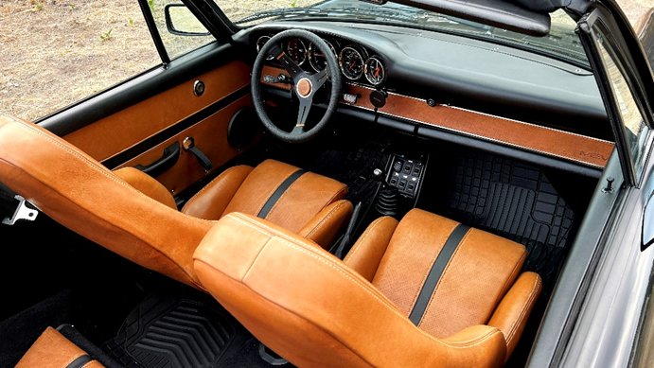
“Each car is also a beautiful work of art, which aims to inspire passion for these beautiful generations of the Porsche 911.”

About MEV Disegno:
MEV Disegno is the first Mexico City-based restomod studio specialized in the restoration and modification of Porsche 911s. Founded by a Porsche enthusiast, the company combines traditional craftsmanship with modern technology to create unique, high-performance vehicles that honor the legacy of Porsche's iconic designs.
###

For more information about the OPUS1 GB and other MEV Disegno builds, please visit https://thespiritofmev.com. Write to contact@thespiritofmev.com.

